Year 7 Science

**Chemistry 1 Test**

**SECTION 1: MULTIPLE CHOICE** (1 mark each)

Circle your answer on the multiple choice answer sheet.

1. Which **change in state** is illustrated?

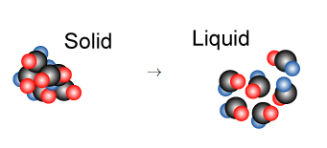

1. Melting
2. Freezing
3. Evaporation
4. Condensation
5. Which best describes a **solid**?
6. Its particles vibrate in place
7. Its particles do not move at all
8. Its particles can flow past each other
9. Its particles are very far apart
10. Which states of matter have **no fixed shape** and **no fixed volume**?
11. Gas and liquid
12. Liquid and solid
13. Plasma and gas
14. Solid and plasma
15. Which statement best describes why gases are **easily compressed**.
16. The particles can diffuse
17. There is a pressure between particles squashing them together
18. There is great energy between the particles allowing them to change
19. There is a lot of a space between the particles.
20. The definition of **melting point** is:
21. the temperature at which a liquid changes to a gas
22. the temperature at which a solid changes to a gas
23. the temperature at which a liquid changes to a solid
24. the temperature at which a solid changes to a liquid.
25. A **physical change** is
26. When a substance is formed
27. One that can easily be reversed.
28. When bubbles, smell or a colour change can be released.
29. Also called a chemical reaction
30. Which of the following is **not** a sign that a chemical change has taken place?
31. Melting or evaporating
32. A colour change
33. Bubbles or smell
34. A change in temperature
35. Which of the following is a **chemical change**?
36. Sawdust is produced from wood being cut by a power saw
37. Water freezes to form ice
38. Fireworks explode in a colourful light display
39. Juice is obtained from an orange.
40. Which of the following would **not** be a physical change?
41. Freezing water to make ice cubes
42. Melting gold to make jewellery
43. Burning gasoline in a lawn mower
44. Boiling water for soup
45. To separate a mixture of **paper clips and sand**, Joe should use
46. Wind separation
47. Distillation
48. Magnetic separation
49. Decanting
50. To separate **two or more liquids**, you would use
51. Distillation
52. Chromatography
53. Centrifugation
54. Filtration
55. Which of the following pictures shows **decantation**?

a) 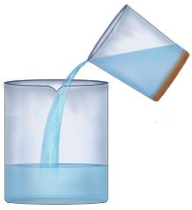b) 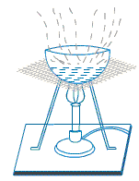

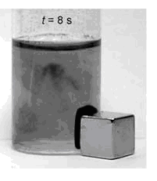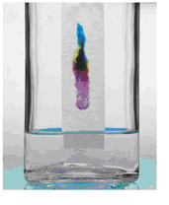

c) d)

1. **Distillation** is not useful for
2. Purifying water
3. Making distilled water
4. Making essential oils or alcoholic liquors
5. Extracting pure salt from sea water
6. A student wishes to obtain **fresh water from salt water**. The best way to do this is by:
7. Filtration
8. Evaporation
9. Distillation
10. Decanting
11. If you were planning to collect salt from sea water, which of the following pieces of apparatus would be of **least use**?
12. Filter funnel
13. Evaporating basin
14. Bunsen burner
15. Tripod



**Chemistry I Test**

**NAME: ______**

**FORM:** **DATE:**

Multiple Choice Short Answer Total

**/15**

**/15**

**/30**

**SECTION ONE:** Multiple choice answers

Cross (X) through the correct answer.

|  |  |  |  |  |
| --- | --- | --- | --- | --- |
| **1** | a | b | c | d |
| **2** | a | b | c | d |
| **3** | a | b | c | d |
| **4** | a | b | c | d |
| **5** | a | b | c | d |
| **6** | a | b | c | d |
| **7** | a | b | c | d |
| **8** | a | b | c | d |
| **9** | a | b | c | d |
| **10** | a | b | c | d |
| **11** | a | b | c | d |
| **12** | a | b | c | d |
| **13** | a | b | c | d |
| **14** | a | b | c | d |
| **15** | a | b | c | d |

**SECTION 2: WRITTEN**

**Write your answers in the spaces on the answer sheet provided.**

1. Label each process as a physical or chemical change. (6)

|  |  |
| --- | --- |
| Slicing potatoes for fries |  |
| A nail rusting |  |
| Baking cookies |  |
| Butter melting |  |
| Food spoiling |  |
| You cut your hair |  |

1. Explain **step by step** how you would separate a mixture of sand, sugar and iron filings, so that you could recover each part of the mixture in a relatively pure form. (4)

________________________________________________________________________________________________________________________________________________________________________________________________________________________________________________________________________________________________________________________________________________________________________________________________________________________________________________________________________________________________________________________________________________________________________________________________________________________________________________

1. Explain what the term “**saturated solution**” means. (2)

__________________________________________________________________________________________________________________________________________________________________________________________________________________________________________________________________________________________________________________________________________________________________________________________________________________________________________________________________________________________________________________________________________________________________

1. Filtration is used widely around the home and all around us. Give **two** examples of filters used in every-day life. (2)

FILTER A __________________________________________

FILTER B __________________________________________

1. When cooking rice it is important to wash the rice in water to remove the starch on the rice grains. After washing the rice, the water is removed by pouring off the water.

What **type of separation** is this? (1)

___________________________________________________________________________

**END OF TEST (OUT OF 30 MARKS)**